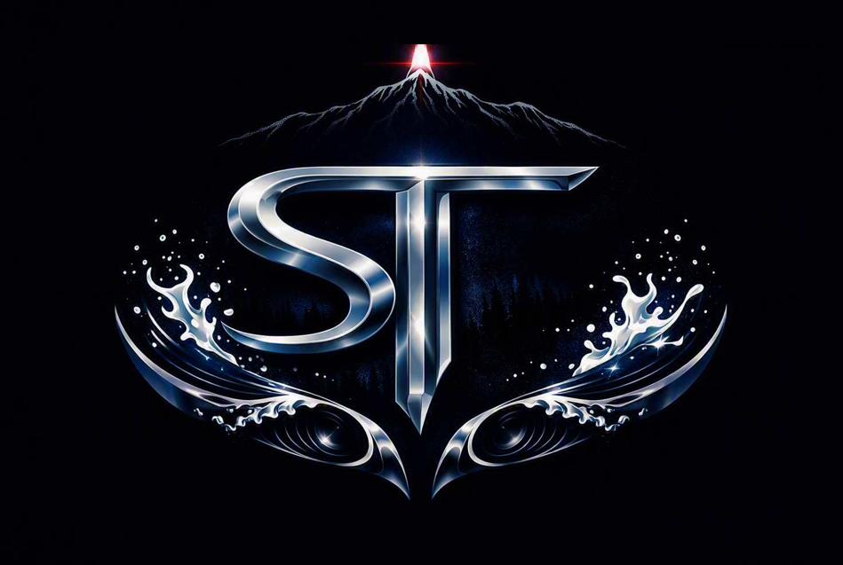
COMPETE. EXPLORE. UNWIND.
Aurora's First 21+ Adult Aquatic Sports Destination
Terry Rust — Founder
(720) 590-9751 | Splash.This@outlook.com

01 | WHAT IS SPLASH THIS?

Splash This™ is a 21+ adult-only aquatic sports facility in Aurora, Colorado — the first of its kind in the United States. This is not a water park. This is not a family pool. This is a destination built for adult athletes, veterans, competitors, and explorers who deserve a world-class water experience on their own terms.
Five immersive Realms — each purpose-built for a distinct adult aquatic experience — connected by a signature waterslide transition system found nowhere else in the country. Engineered for competition, adventure, recovery, and relaxation. All under one roof. All adults-only. All elite.

02 | THE FIVE REALMS

Competition Realm
A Wipeout-inspired water obstacle course unlike anything else in the country, but made entirely Splash This's own. Guests take on a series of in-and-out-of-the-water challenges, navigating obstacles that test balance, strength, and nerve. This is adult competition reimagined, physical, unpredictable, and impossible not to watch.
Surf Realm
Beginner to advanced adult surf stations — every wave calibrated for grown-up athletes ready to push their limits.
Exploration Realm
The Exploration Realm is the high-intensity adventure zone — part natural wonder, part adrenaline machine. Eight signature features deliver speed, physical challenge, and immersive sensory experience throughout.
- Waterfall Climb — A cascading waterfall guests can climb beside or behind, with plunge pool below
- Rock Wall — A rugged natural rock wall rising above the water; climb it, conquer it, drop in
- Tree Root System — A dramatic, gnarled tree root structure guests navigate upward before plunging into the water beneath — one of the most visually striking features in the facility
- High-Speed Adventure Slides — Multi-story speed slides with velocity tracking and personal best displays at exit
- Free-Fall Drop Chutes — Vertical drop slides with near-freefall descent for adult thrill experience
- Racing Slides with Timing Displays — Side-by-side competitive slide lanes with real-time timing and daily leaderboard rankings
- Exploration Current Channel — Variable-depth challenge circuit with pull stations, current resistance zones, underwater navigation gates, sprint sections, and submerged obstacle passages
- Video-Enhanced Immersion Environments — Large-scale projection systems create environmental themes that respond to guest movement and time-of-day programming
The Amazon
Cold plunge pools, contrast therapy circuits, hot tub soaks, eucalyptus steam rooms — elite recovery, beautifully executed.
The Venetian Drift
A very slow-moving river designed for adults who want to unwind. Stops along the route offer bars, lounges, and light snacks — places to pull off, grab a drink, hang out, and when the music is right, just soak it all in before drifting on.

03 | THE MARKET OPPORTUNITY

410,000+
Aurora residents — fast-growing, young, and active
3M+
Denver-Aurora metro catchment area
21,265 + 88,000+
Aurora veterans & Buckley Space Force Base military community
90M+
Annual passengers through Denver International Airport — just 11 miles away
ZERO
Dedicated adult aquatic facilities in Aurora or the Denver metro
The market exists. The demand is proven. The competition is nonexistent.

04 | THE BUSINESS MODEL

Revenue Stream | Details
Admission & Memberships | Day Passes from $65 — Athlete, Explorer, and Lounge membership tiers
Food & Beverage | Full adult bar, craft beer, sports nutrition — avg. $22–$28 per guest
Cabanas & Private Events | Premium cabana rentals, corporate buyouts, and private event hosting
Championship Tournament | Annual Splash This™ Open — ticketed, sponsored, nationally promoted
Sponsorship & Merchandise | Brand partnerships & Poseidon-branded apparel and gear line

05 | THE NUMBERS

YEAR 5 PROJECTED REVENUE
$47.3M
YEAR 5 EBITDA
$31.8M
CAPITAL STRUCTURE
SBA 504/7(a) + Private Investor Equity + Owner Equity
BUILD TIMELINE
Phase 1 Operational — Year 2 | All Realms Active — Year 3

06 | THE FOUNDER

Terry Rust — founder, engineer, operator. Built this concept from the ground up as a solo Metropolitan State University of Denver senior engineering capstone project. Background in industrial operations and safety management — the same discipline that runs power plants and refineries, applied to world-class aquatic design.
One student. One vision. Zero corners cut.

“Splash This™ is not a water park. It is a movement.”

